**COMSATS University Islamabad (CUI)**

**Assignment-01**

**(CLO-01)**

**Project Proposal**

(SCOPE DOCUMENT)

**for**

**Depression Detector Chat Bot**

Version 2.0

***By***

**Muhammad Ahmed Raza SP21-BCS-003**

**Khan Sharjeel Khan SP20-BCS-041**

**BCS-4-A**

***Supervisor*Mr. Tehseen Riaz Abbasi**

***Bachelor of Science in Computer Science (2021-2024)***

Contents

Abstract 1

1. Introduction 2

2. Problem Statement 2

3. Problem Solution/Objectives of the Proposed System 2

3.1 Objectives 2

4. Related System Analysis/Literature Review 2

5. Vision Statement 3

6. Advantages/Benefits of Proposed System 3

7. Scope 4

8. Modules 4

8.1 Module 1: Administration 4

8.2 Module 2: User Profiling 4

8.3 Module 3: Emotion Detection 5

8.4 Module 4: Psychological Test 5

8.5 Module 5: Self Care Toolkit 5

8.6 Module 6: Appointment Management 5

8.7 Module 7: Activity 6

8.8 Module 8: Feedback 6

9. System Limitations/Constraints 7

10. Software Process and Design Methodology 7

11. Data Gathering Approach 7

12. Concepts 7

13. Tools and Technologies 8

14. Project Stakeholders and Roles 8

15. Module based Work Division 8

16. WBS and Gantt Chart 9

17. Mockups 9

18. Conclusion 6

19. References 6

20. Plagiarism Report 6

**Project Category:**

□ **B-**Web Application/Web Application based Information System □ **C-**Problem Solving and Artificial Intelligence □ **E-**Smartphone Application

# Abstract

The reason for this project is to provide a reliable way to combat depression by identifying people who are inflicted by it using chat bot. Currently, mental issues including depression are a topic that is heavily criticized and not dealt with properly. Such issues are not met with the level of urgency that’s suitable to handle them. A large portion of public suffer from depression without a clear cure.A lot of the common folk suffer from mental and physical stress from their daily struggles. Our project will provide a way to assist such individuals instead of shunning them. Our application will act as a source of stress relief. It will provide emotional support to people ailing from depression. It will provide an AI partner to unload all your mental stress. Our main goal is to help individuals facing such issues come forth and seek help instead of falling deeper into a pit of depression and loneliness.

# Introduction

Throughout the human history, the concept of the depression is being caused by the evil spirits and demons which causes the physical disease like mental illness. Greek and Roman doctors and philosopher use different therapy to cure their patient from this illness. Today’s modern world has shown that technology can be used to detect the depression level so that his/her treatment would be easy. A philosopher MOHR ET AL suggest that behavioral intervention technologies (BITs) that help chatbot to address the mental health condition. Depression chatbot detector are the computer programs that uses chat and images to detect the depression level. The depression chat bot help doctors and philosopher to detect the depression level so that they can start their treatment.

# Problem Statement

Depression is a disease which are very common now a days. If you might suffer from depression, you may not know what to do and where to being to get help, especially, when you never experience this feeling before. This disease is such kind of mental illness that doesn’t allow patient to what to do and how to stay calm. Even the Doctor have to check your history, background about this disease and couldn’t gave you treatment on the first appointment, but this is the certain kind of disease that if the treatment is not started at the initial stage than the situation would become worse. So, we are making this software that can detect the depression level within few minutes and the doctor can start the treatment of the patient at the initial stage.

# Problem Solution/Objectives of the Proposed System

Depression detector chat bot system will be a smartphone and web application that will help the patient to detect their depression level and it also help the doctor and physiologist to diagnose a depression disease so that they can start his/her treatment in time. We use Natural Language Processing (NLP) in this system, that is used to build the machine that understand and response to the text and the voice data just like human being. this system simply asked multiple choice question from the patient or required a face image of the patient. Through this system can check the level of depression of the patient. However, it will reduce the cost as well as time.

## Objectives

The following are objectives of this system.

**BO-1:** Reduce the cost, time and of the user by 60%.

**BO-2:** To allow user to check their depression state (mental health).

**BO-3:** Reduce the effort the effort of the user by 40%.

**BO-4:** To allow user to receive a further suggestion from the system such as an appointment.

# Related System Analysis/Literature Review

The following are the systems that are related to our system.

Table 1 Related System Analysis with Depression Detector Chat Bot

|  |  |  |
| --- | --- | --- |
| **Application Name** | **Weakness** | **Proposed Project Solution** |
| * Depression test * <https://play.google.com/store/apps/details?id=com.depression.test> | * Do not arrange appointments between the patient and Doctor/physiologist. * Do not give suggestion to consult with a doctor | * Arrange proper appointments between the patient and Doctor. * Also give suggestion for proper treatment |
| * Dealing with Depression * [Dealing with Depression - Apps on Google Play](https://play.google.com/store/apps/details?id=com.fatbelly.dealingwithdepression) | * Do not have any Doctor /physiologist | * Arrange Doctor to examine patients |
| * Mental Health Tests * [Mental Health Tests - Apps on Google Play](https://play.google.com/store/apps/details?id=org.minddiagnostics) | * Do not offer Self Care Toolkit | * Must arrange Self Care Toolkit for best treatment and healthy routine |

# Vision Statement

For a patient or doctor who wants to check their depression level through software, the Depression detector chat bot system is web and smartphone application that helps the user to diagnose their depression state(mental health) and suggest a suitable treatment for the disease unlike you go to the doctor and give your family history about the disease and arrange several appointments ,our product will provide us the efficient result without wasting any time and reduce financial burden.

# Advantages/Benefits of Proposed System

The following are the benefits of the Depression Detector Chat Bot.

* Detection of depression is easy
* User time will be saved
* Reduce emotional and financial burden of disease.
* Available for both IOS and android user in the case of smartphone.
* User friendly UI, most of the people about which would aware off.

# Scope

The system is basically designed for the patient who have mental disease (depression) but they didn’t realize that weather it’s a depression or something else. The aim here is to develop a system that enables the patient to detect his/her depression level and make an appointment to a doctor if needed. This system is used on the web and the smartphone application as well.

# Modules

The following are the modules of this project.

## Module 1: Administration

In this module, the Depression Detector Chat Bot will allow admin to manage users, physicians as well as he’ll generate reports.

* **Users Management**

Admin will manage users accounts add, delete or update.

* **Physicians Management**

Admin will manage physicians accounts like add, delete, or update.

* **Reports Generation**

Admin will generate reports for weekly, monthly, and yearly revenues for physicians and for him as well.

* **Comments Management**

Admin will manage reviews, comments, and ratings.

## Module 2: User Profiling

In this module, Depression Detector Chat Bot will be taking input for valid credentials like username, email, password for creating new accounts sign up and login for existing accounts.

* **Sign-Up**

Users and physicians will sign up by using their valid credentials.

* **Sign-In**

Users and physicians will login by using their valid username and password.

* **Update Username and Password**

Users and physicians will update their username and password by email verification.

* **Forget Password**

In case anyone forgot their password, they will reset password by verifying email.

* **Logout**

Users and physicians will end their session.

* **Remember Me**

Users and physicians will save their username and password so that they don’t need to fill them every time on login.

* **Deactivate Account**

Users and physicians delete their account and remove their personal info from Depression Detector Chat Bot.

## Module 3: Emotion Detection

In this module, Chat Bot will capture the images (as an input) of the user from the camera to get his/her face expression so that depression can be detected.

* **Camera**

User can capture his/her live pic from the camera on the device.

* **Gallery**

User can upload his/her image from gallery or documents.

## Module 4: Psychological Test

In this module we will check the mental state of the user through question/answers session. where the user must answer each question in a specific time and at the end the depression meter will give us the result that, categorically on which stage of depression does the user lie. So, based on this result we must decide whether the user must consult to a doctor or not.

* **Test questions/quiz**

Users must answer the question in the specific time. These questions are usually multiple-choice questions, none of the answer will be right or wrong, it is simply used to check the mental state. Every answer to the question is compulsory.

* **Depression meter**

Depression meters tell the user about the depression level based on above functionalities.

* **Prescription**

This prescription is generated based on depression level on depression meter and tell us whether the user must consult to a doctor or not.

## Module 5: Self Care Toolkit

In this module, the system will provide users some routines and guide how to overcome depression.

* **Sleep Routine**

Chat Bot will send reminder to sleep according to time zone.

* **Exercise Routine**

Chat Bot will send reminder for exercise like cardio, yoga, and meditation etc.

* **Healthy Diet**

Chat Bot will suggest healthy diet to users using AI algorithm by calculating BMI of the users.

* **Analyze Progress**

Chat Bot will help users to analyze their progress with the passage of time.

## Module 6: Appointment Management

In this module, Depression Detector Chat Bot will allow users to schedule his/her appointment (online/offline) with the recommended physician.

* **Suggest Physician**

Chat Bot will suggest physicians to users according to their location using AI algorithm.

* **Scheduling Meeting**

Users will select physicians from the suggested list according to budget and time zone. Then select the venue of the meeting. If he/she is around physician so, he/she will go for face-to-face therapy.

* **Cancel Appointment**

Users will cancel appointment within a given span of time otherwise he/she will pay fine of 10 percent of the appointment.

* **Payment**

Users will pay for appointment online as well as offline using different bank accounts or e-wallets.

## Module 7: Activity

In this module, users will save their test results and see their mental improvements day by day.

* **Save Activity**

Users will save results of each depression test.

* **See Recent Activity**

Users will see results of depression tests of last 30 days in the form of graphs, charts, and percentage.

* **Compare Activities**

Users will compare their activities from specific time periods to specific time for checking their improvements after therapy and before therapy.

* **Generate Charts**

Users will allow to generate their activities in the form of charts.

* **Generate Reports**

Users will allow to generate their activities in the form of reports.

* **Appointment Status**

Chatbot will allow physicians to check, update and delete their appointments.

* **Availability**

Chatbot will allow physicians to set their availability time.

## Module 8: Feedback

In this module, users will rate this system and give feedback according to their experience and time they spent on it.

* **Add Reviews**

Users will add their reviews according to their experience.

* **Ratings**

Users will give ratings according to their experience.

* **Edit Ratings/Reviews**

Users will edit their reviews/ratings if they found anything change in the behaviors of chat bot.

* **Suggestion Emails**

Users will allow to send any suggestion on chat bot email to improve anything.

# System Limitations/Constraints

The following are the constraints of this system.

**LI-1:** Physicians are only available for 15 hours from 8:00 AM to 11:00 PM for every time zone.

**LI-2:** If user/physician will deactivate their account, they will have 30 days to login again. If they login within 30 days their account will recover and will not deactivate

**LI-3:** For online meeting, chat bot will also need active internet connection for user and physician.

# Software Process and Design Methodology

We are going to use **Incremental process model** for the proposed project and the following are the reasons why we choose this model.

* Requirements are clearly described.
* Small releases are appreciated.
* Changes and updates are also allowed.
* It will also help to reduce the technical risk in development.

We are going to use **Object Oriented approach** for this project and the following are the reasons why we choose this approach.

* It will help in during system updates, maintenance, and adaptation.
* It will minimize the cost during updates.
* It will help to reduce dependencies.

# Data Gathering Approach

We tried to gather data using different approaches. The following are some data gathering techniques which we used in this project.

* Brainstorming
* Document analysis
* Interviews
* Websites surfing
* Observing related software

# Concepts

The following are some new concepts which we learn during this project.

**Concept-1:** **Artificial Intelligence:** It is a sub domain of machine learning which trains the computer to take its own decisions.

**Concept-2:** **Natural Language Processing:** The ability of computer to understand human language and response humans in their language.

**Concept-3:** **Machine Learning:** The AI application which trains computer to learn from previous experiences.

**Concept-4:** **Deep Learning:** The subdomain of machine learning which automatically improves its abilities just like humans by using different AI algorithms.

# Tools and Technologies

Following are the tools and technologies.

Table 2: Tools and Technologies for Proposed Project

|  |  |  |  |
| --- | --- | --- | --- |
| **Tools and Technologies** | **Tools** | **Version** | **Rationale** |
| Visual Studio Code | 1.59 | IDE |
| MongoDB | 5.0 | DBMS |
| Firebase | 9.12.1 | DBMS |
| MS Project | 2016 | Project Management |
| MS Word | 365 | Documentation |
| MS Power Point | 365 | Presentation |
| Figma | 1.7 | Mockups Creation |
| **Technology** | **Version** | **Rationale** |
| Python | 3.9.0 | Programming language |
| JavaScript | 2.2.0 | Programming language |
| TensorFlow | 2.7.0 | Library |
| React | React 17 | Library |

# Project Stakeholders and Roles

Write down the project stakeholders and their roles.

Table 3 Project Stakeholders for Proposed Project

|  |  |
| --- | --- |
| **Project Sponsor** | COMSATS University Islamabad, Islamabad Campus |
| **Stakeholder** | * Muhammad Ahmed Raza (SP21-BCS-003) * Khan Sharjeel Khan (SP20-BCS-041) * Project Supervisor Name: Mr. Tehseen Riaz Abbasi |

# Module based Work Division

Table 4 Team Member Work Division for Proposed Project

|  |  |  |
| --- | --- | --- |
| **Student Name** | **Student Registration Number** | **Responsibility/ Module / Feature** |
| Muhammad  Ahmed Raza | (SP21-BCS-003) | Mr. Ahmed (Module 5-8)  Web development. |
| Khan Sharjeel Khan | (SP20-BCS-041) | Mr. Sharjeel (Module 1- 4)  App development. |

# WBS and Gantt Chart

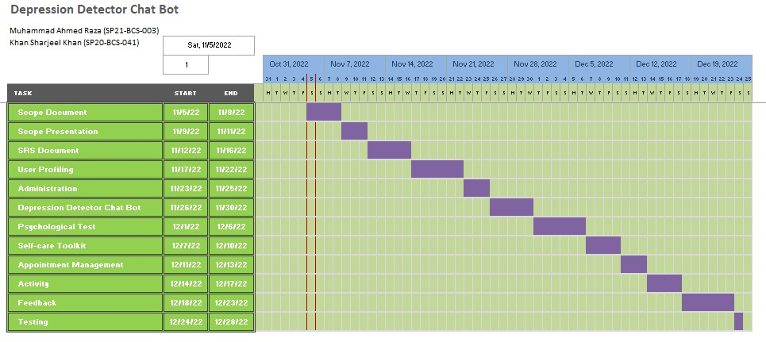This is the Gantt chart of this system.

Figure

# Mockups

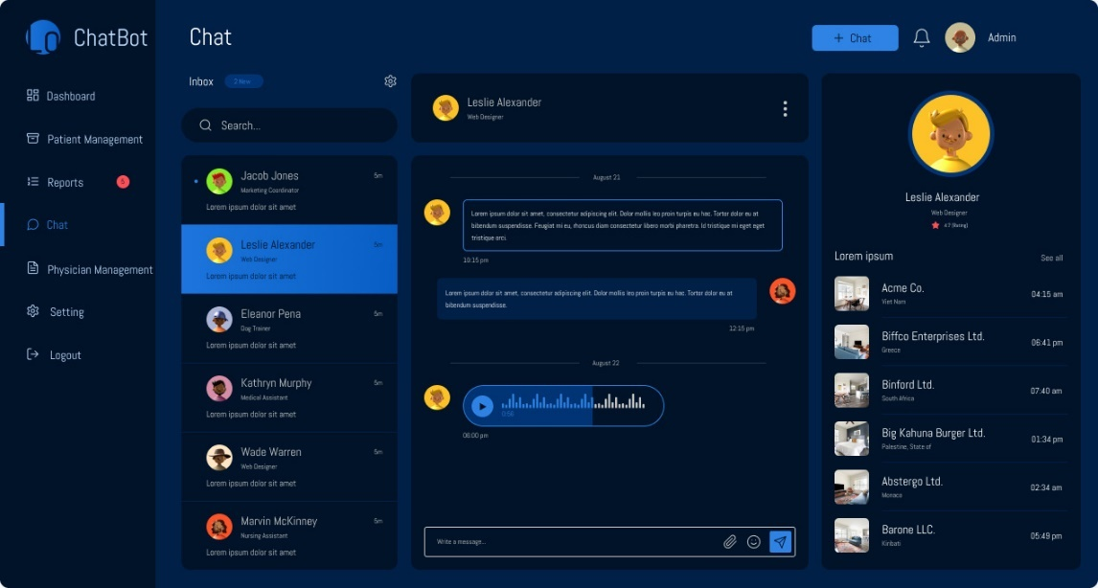The mockups of proposed project are given below:

Figure

**Description: This is the admin panel of proposed project**

Figure

**Description: This is self-care toolkit of web page.**

Figure

**Description: This is chat room of a user with bot of an app.**

Figure

**Description: This is chat room of a user with bot of web page.**

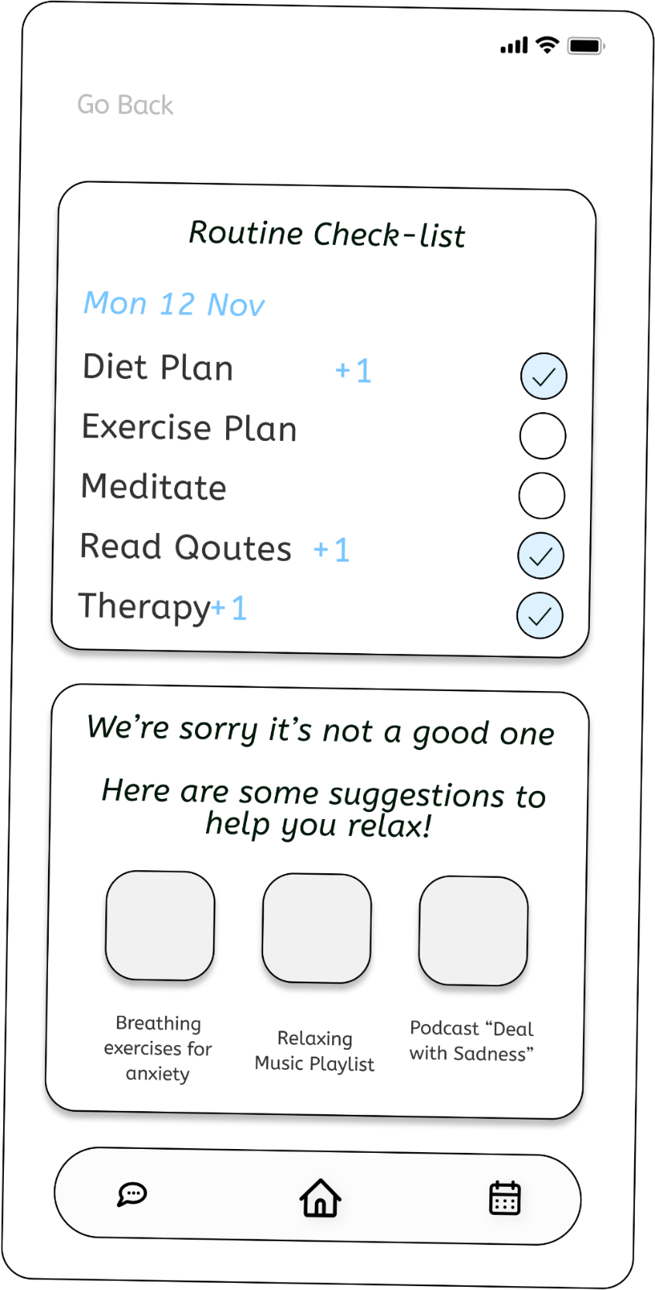

Figure

**Description: This is daily routine check of a user of an app.**

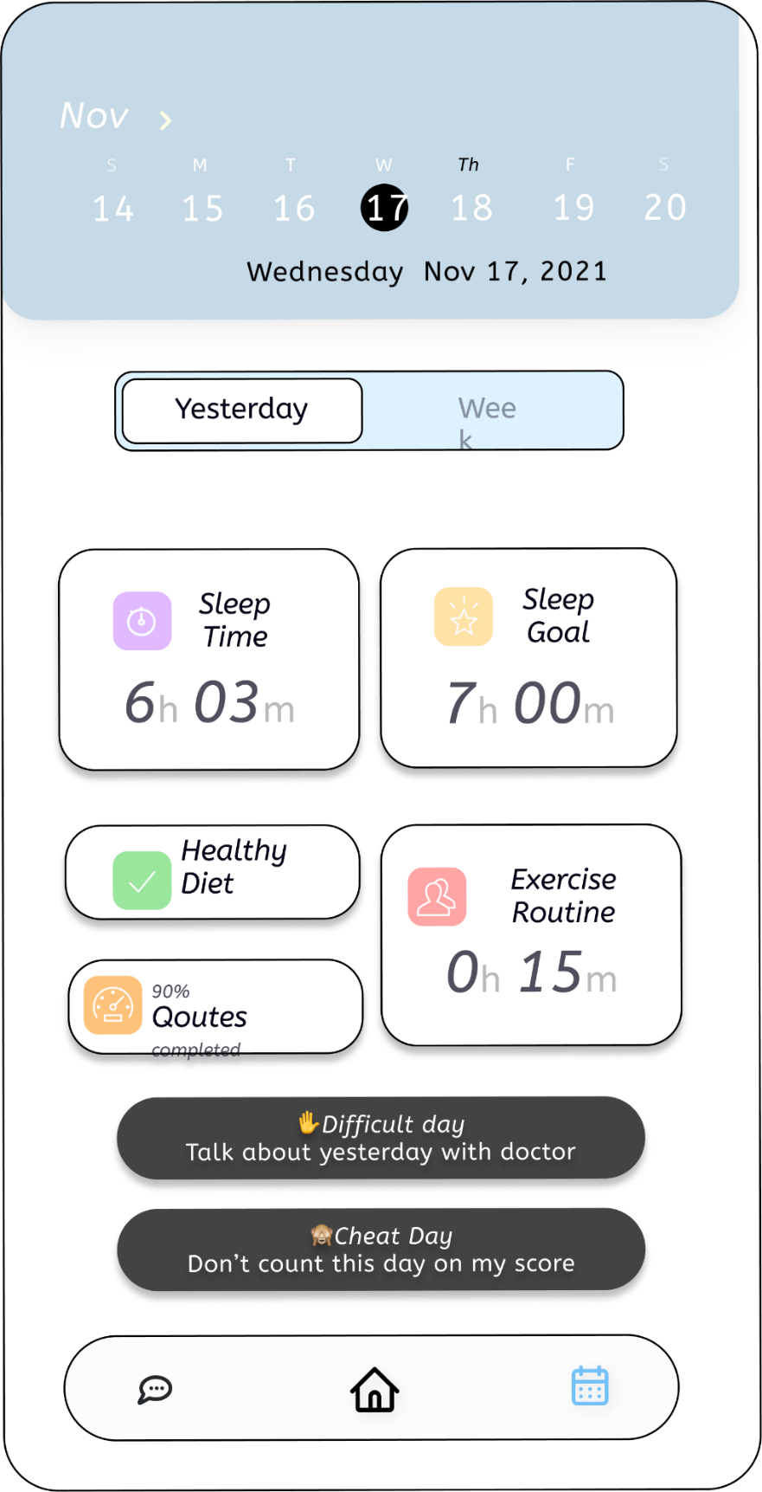

Figure

**Description: This is self-care toolkit of a user of an app.**

# Conclusion

We proposed a Depression Detector Chat Bot for sensing negative emotions using AI algorithms by chatting with them. There is many comparable software that are providing these services, but we are going to provide therapy services as well online or offline according to users’ demand. We are also providing a self-care toolkit for users which help them to improve their mental as well as physical conditions. In our future work, we will consider users privacy and improve our privacy policy according to users’ demand.

# References

These are the links that we used to get help regarding this proposed project.

**World Wide Web**

Medium “Testing Chat bot for stress management. Internet:

<https://code.likeagirl.io/i-tested-out-a-chatbot-for-stress-management-heres-the-scoop-58b007b0e2e8>, Feb 13, 2019.

Chatbot life “Chat bot performance testing. Internet:

<https://chatbotslife.com/first-steps-in-chatbot-performace-testing-with-botium-box-efe6f12bcc50>, Jan 11, 2022.

Mdpi “Mental Health Chat bot. Internet:

<https://www.mdpi.com/1424-8220/22/10/3653/htm> , May 11, 2022.

# Plagiarism Report

This is the plagiarism report for this proposed document.

